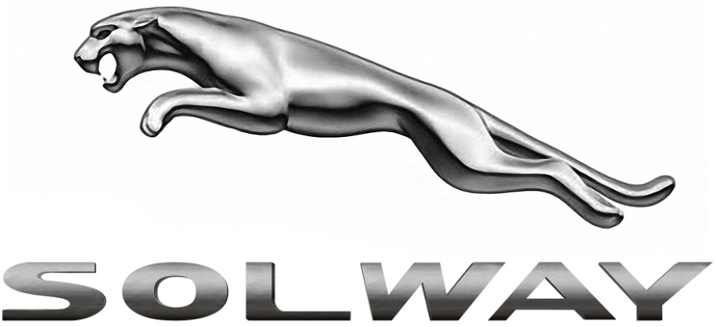
Model

Owner -
Year of Manufacture
Year Acquired
Cubic Capacity

