Regional report August 2019 - Cumbria & the Borders Solway Jaguar Region

First of all, Please remember our August meeting has a change of venue. We are meeting on Tuesday 6th August at The Lakeside, Brayton Park, Aspatria, CA7 3PY
June proved to be a very active month. Ten members attended the Jersey International Motoring Festival, where we were greeted on the opening day by the Jersey JEC Region. The Jersey branch had the honour of taking part in the opening parade of cars and the icing on the cake was when we were invited to occupy any available seats in their cars and take part in the parade. Too good an opportunity to pass up and what an honour to be able to take part.
Other notable events included the Whitby Weekend which combined attendance at the JDC Hardwick Hall with over 100 other Jaguars. A fantastic weekend and a superb show as well. Plans are already in place for another weekend next year.
July's meeting included our 'Ride and Try' evening, where members take the opportunity to have a ride in other members cars, including an incredibly powerful Porsche 911 and BMW M6. Our local dealer, Lloyd Carlisle brought along their very impressive I-PACE demonstrator which proved very popular. I think everyone who turned up had a ride in it.
The summer season is in full swing so please take a note of some of the forthcoming events; 3rd August, Cockermouth Show - contact Andy Stalker. Dalemain 18th August (Closing Date is 30th July) Contact Robin Heslop. And finally, a date for your diaries. This year's Christmas lunch will be held at the Roundthorn on the 15th December. Full details of all events are in the newsletter.
*********************************************************************************************
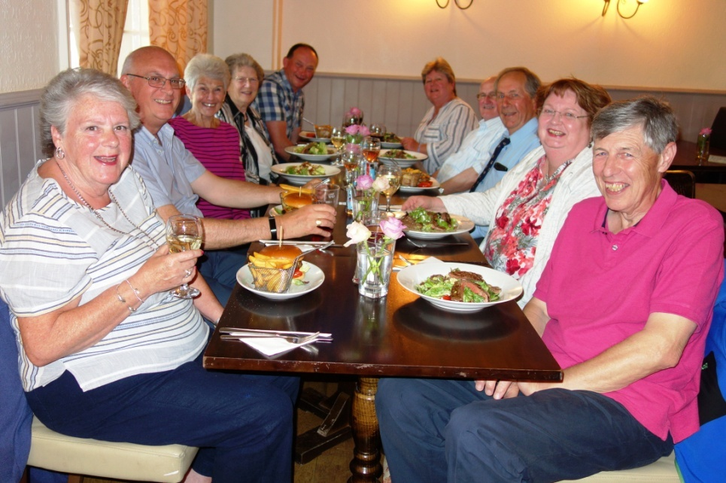
Solway Members Jersey Trip

