Regional Report July 2019 - Cumbria & the Borders Solway Jaguar Region

Our Annual General Meeting and members Concourse evening followed by a superb free buffet was held in May. Jim Kidd and John Grainger stood down from the committee after many years of valued service and we are pleased to announce that Barbara Hemmingway has joined the committee. Awards for the concourse were handed out and our special Chairman's cup was awarded to Jean Mallaband in recognition of her tireless work throughout the year.
Our first major event of the season at the ESPCC Cumbria International Motor Show was a fantastic success with over 30 cars on the Jaguar stand ranging from a 1950s XK150 to a 3 month old F Type.
Our next club night on Tuesday 2nd July is our 'Ride and Try' evening, where members take the opportunity to have a ride in other members cars. Our local dealer Lloyd Carlisle, will be bringing along their I-PACE demonstrator which is sure to be popular.
The summer season is in full swing so please take a note of some of the forthcoming events; 7th July, Distington Vintage Rally - contact Ken Jardine. 28th July, Clapham village fair - contact Carolyn Heslop. 3rd August, Cockermouth Show - contact Andy Stalker. 4th August, Netherby Hall contact Brian Green. Full details of all events are in the newsletter.
New members are always welcome, if you wish to join us on the First Tuesday of the month at Penrith Golf Club CA11 8SG
*********************************************************************************************
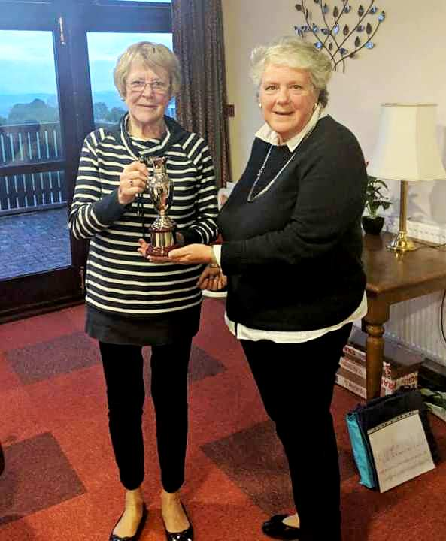
Jean Mallaband receiving this year's Chairman's Cup

