Regional Report February 2019 - Cumbria & the Borders Solway Jaguar Region

Similar to a lot of Regions, it has been a quiet month with little to report on winter activities. Some members did attend the South Lakes Motor Museum Boxing day meet and of course we had our traditional Winter Warmer and Auction, so watch out for a full report in our next newsletter.

We are looking forward to a full calendar of events for this Spring, including Drive it day (details to follow) and the Cumbria International Motor Show in Kendal. Make sure you let Alex know if you are attending the show as he needs to firm up numbers as soon as possible.

Finally - One for the diary for February's club night. We have Cumbria's Motoring Correspondent, Broadcaster and author of over 30 books, Malcolm Bobbitt, presenting to us on his life in Journalism. An evening not to be missed.

New members are always welcome, if you wish to join us on the First Tuesday of the month at Penrith Golf Club CA11 8SG

*********************************************************************************************
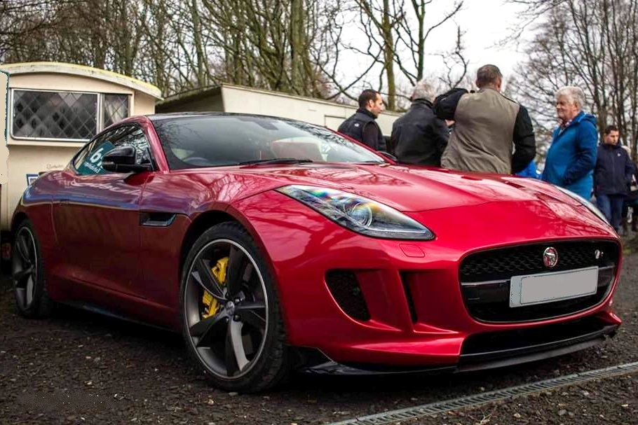
Andy Stalkers stunning 5.0 Litre F-Type R at the Boxing Day Classic Ride and Drive event

