Regional Report January 2019 - Cumbria & the Borders Solway Jaguar Region

Thank's go to Carolyn and Robin for organising this year's Christmas lunch, attended by forty two members, partners and friends who enjoyed an excellent afternoon and evening. Our raffle was a huge success raising £145 with a further £39 raised on our closest to the bottle coin toss competition. One lucky (or should I say skilful) member winning a bottle of malt whiskey for just a pound. Well done Jonathan.

Thank's also go to those for making last month's Christmas quiz evening such a great success, supplemented for the second year running by the best sweet mince pies in Cumbria. A great evening's entertainment to round off the year.

Remember - there will be no monthly club night on the first week in January, but members are reminded of our January Winter Warmer and Grand Auction, which takes place at Thursby Village Hall on Sunday 20th January from 12:30pm. Remember to bring some interesting items you no longer have a use for, as well as those unwanted Christmas goodies for our Grand Auction.

Finally - One for the diary for February's club night. We have Cumbria's Motoring Correspondent, Broadcaster and author of over 30 books, Malcolm Bobbitt, presenting to us on his life in Journalism. An evening not to be missed.

New members are always welcome, if you wish to join us on the First Tuesday of the month from February 2019 at Penrith Golf Club CA11 8SG

*********************************************************************************************
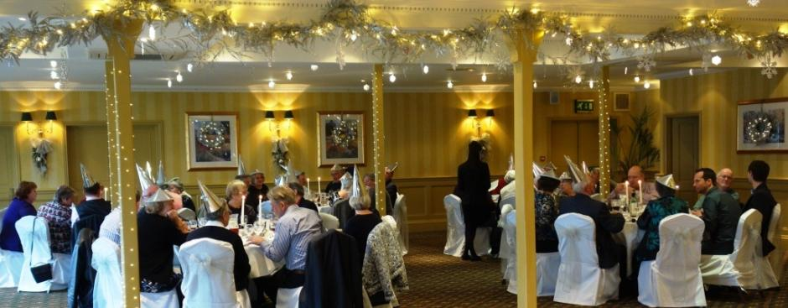
Solway Jaguar members enjoying Christmas lunch

